

CS6314 – Web Programming Languages

ASSIGNMENT 02

Design and implement user interface for CS Master’s Degree plan using HTML, CSS, JavaScript & PHP

Hongyi Wang

6/16/2016

1.login.php

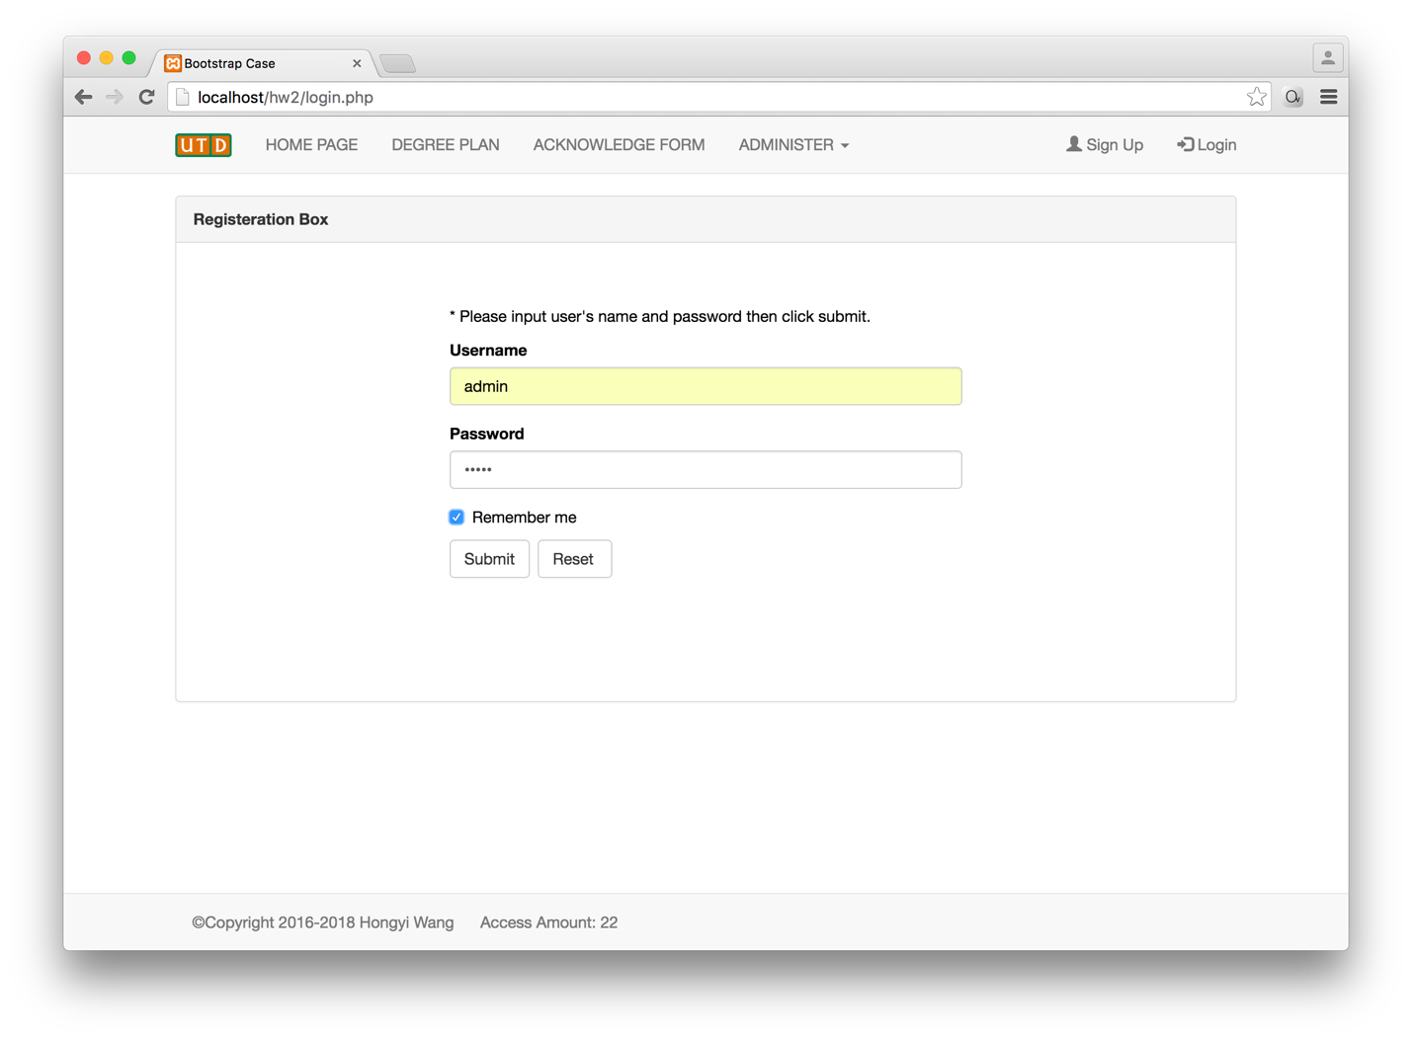

2.index.php

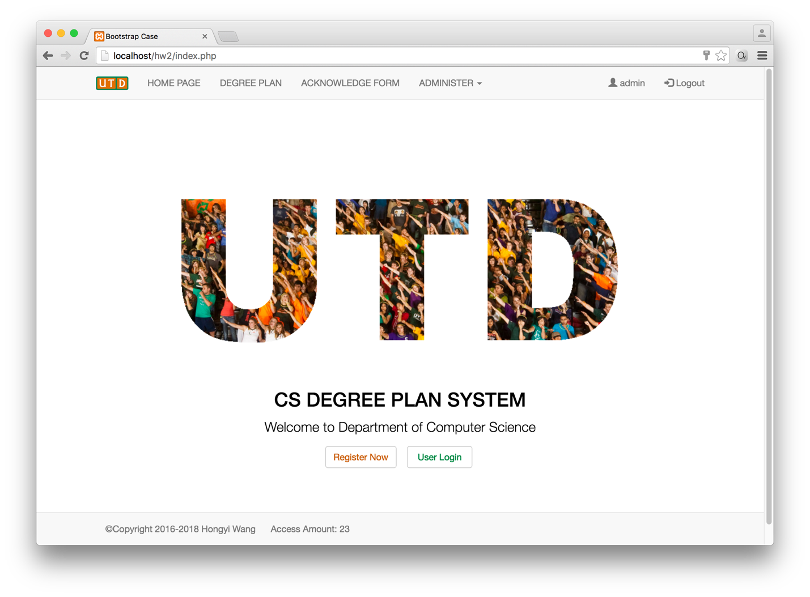

3. admin.php

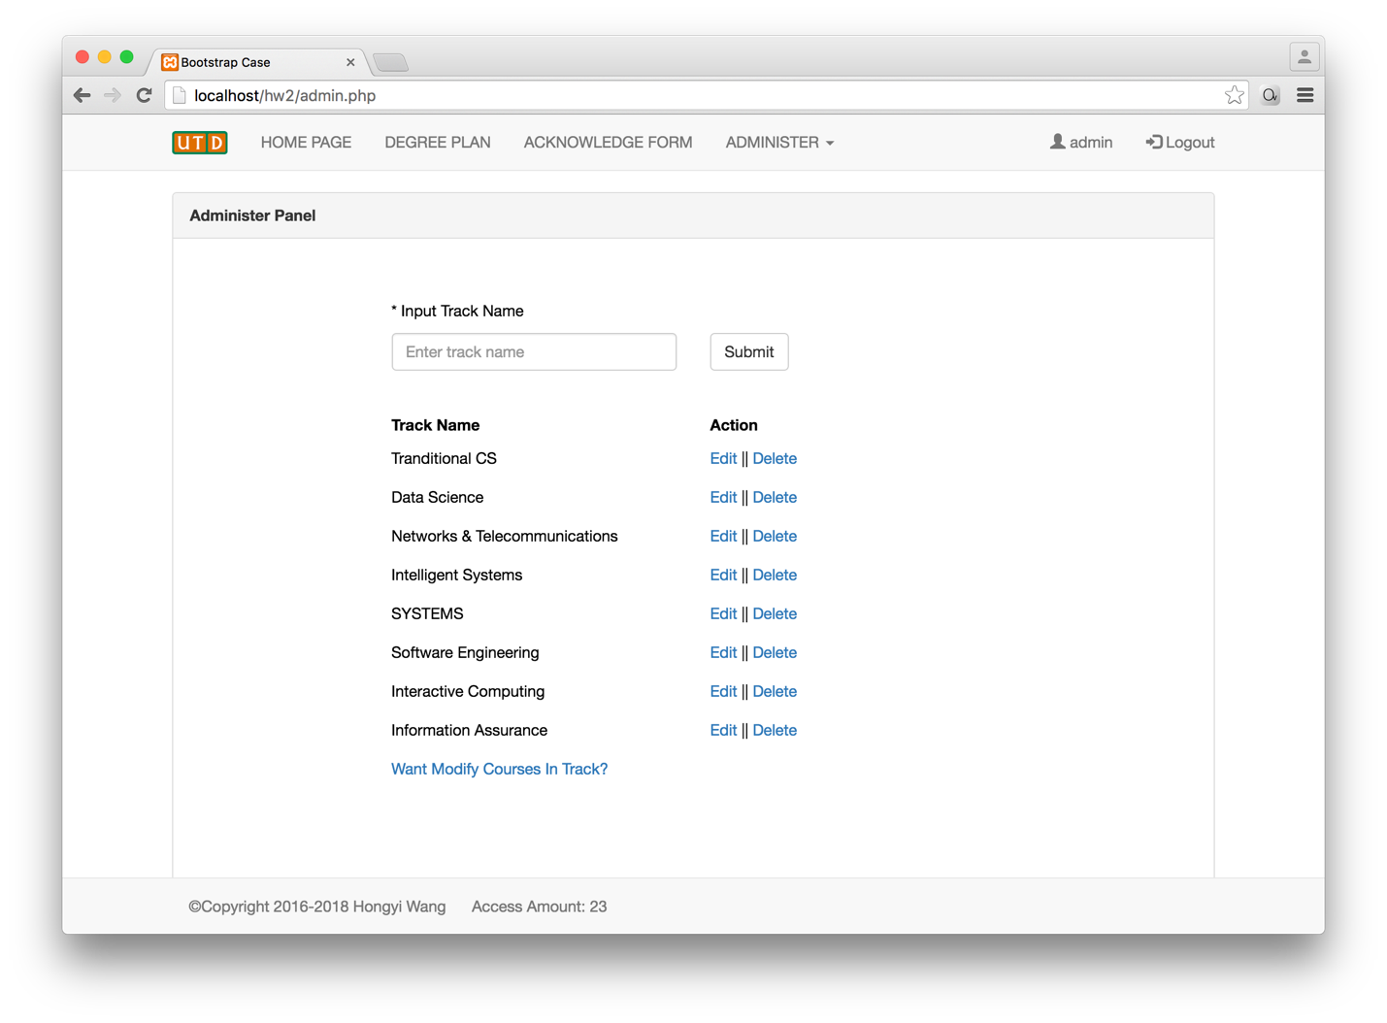

4. admin_course_list

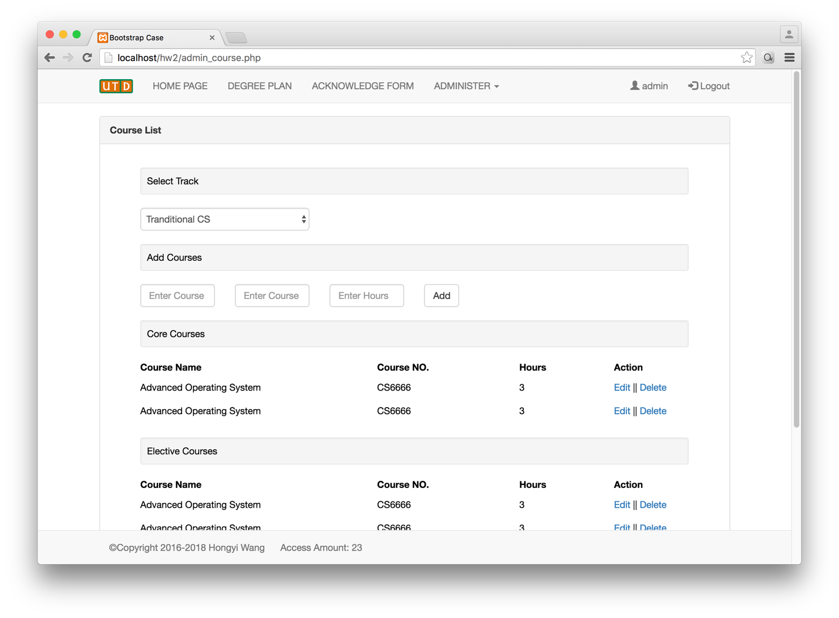

5. admin_manage_user

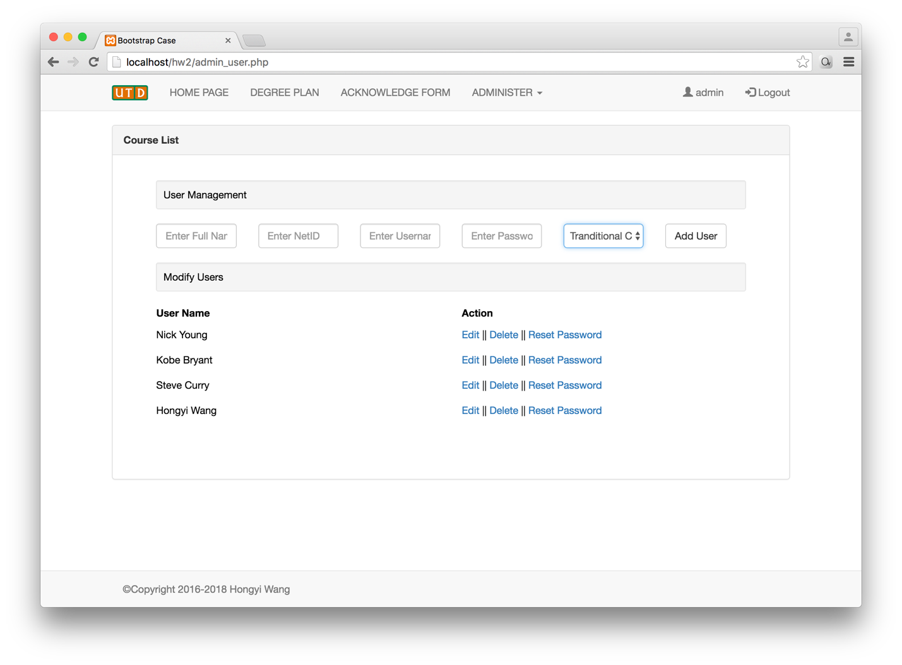

6.degree_plan.php

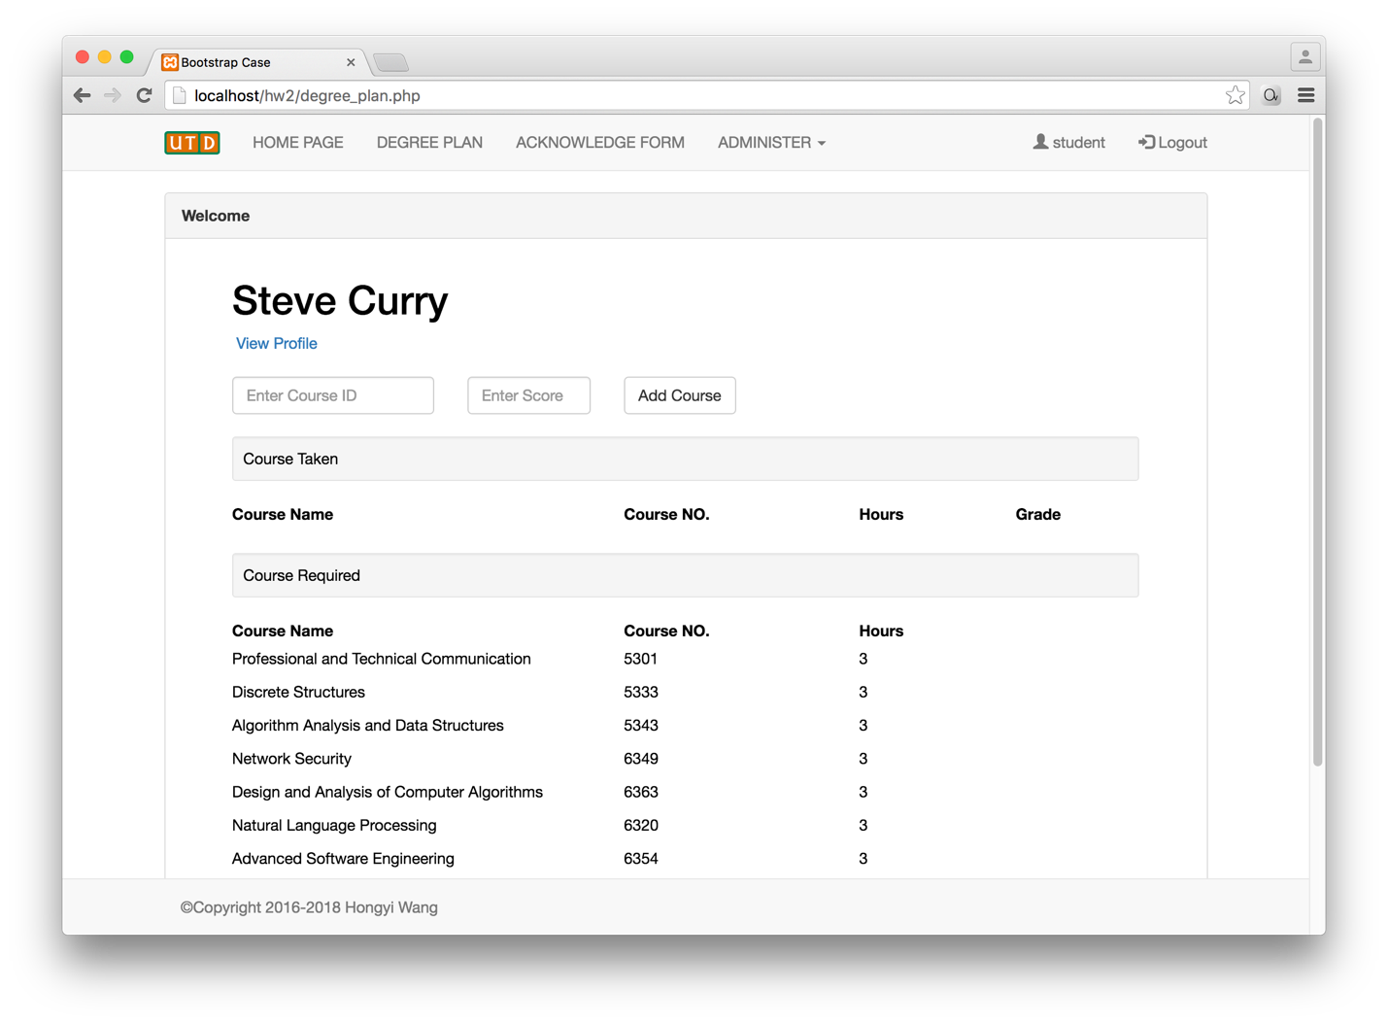

7.degree_plan (add course)

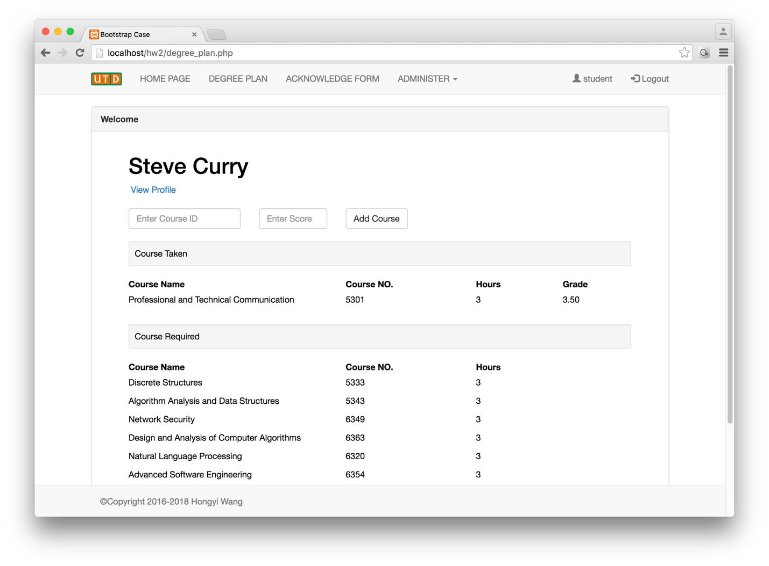

8.stu_profile.php

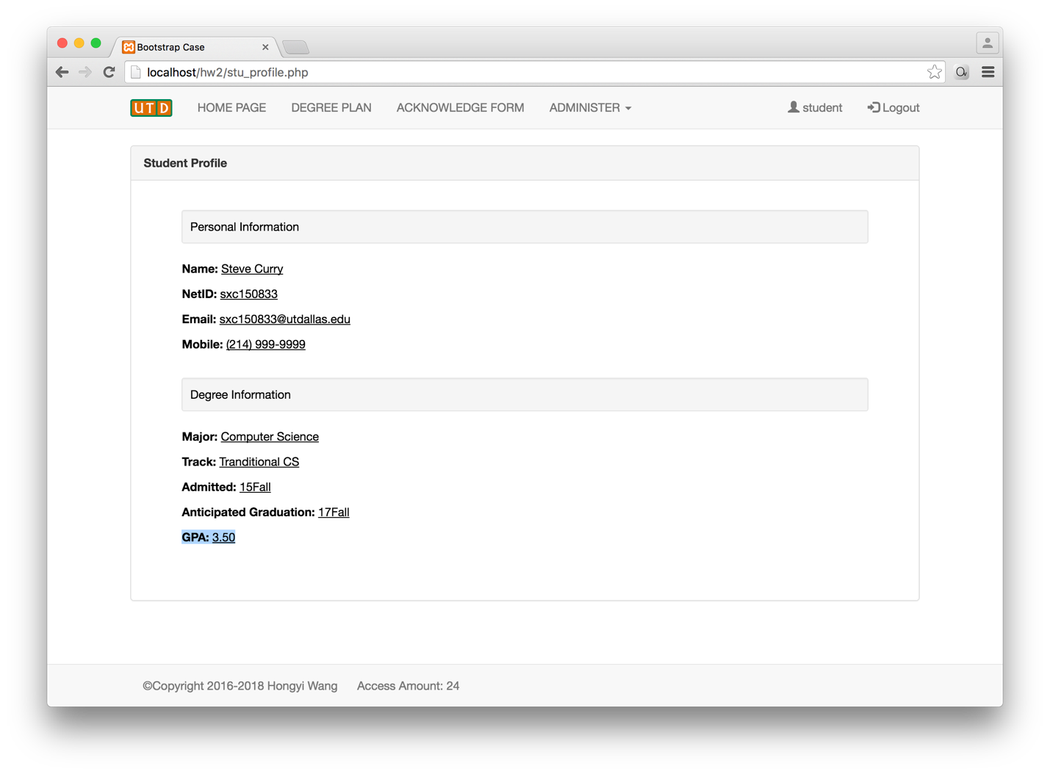

9.XAMPP MySQL Database

